Bailey, Taylor 04/16/18 18SP_F2 IST190 LINUX Essentials (W02)

Lab7

Lab7-13.6-5c

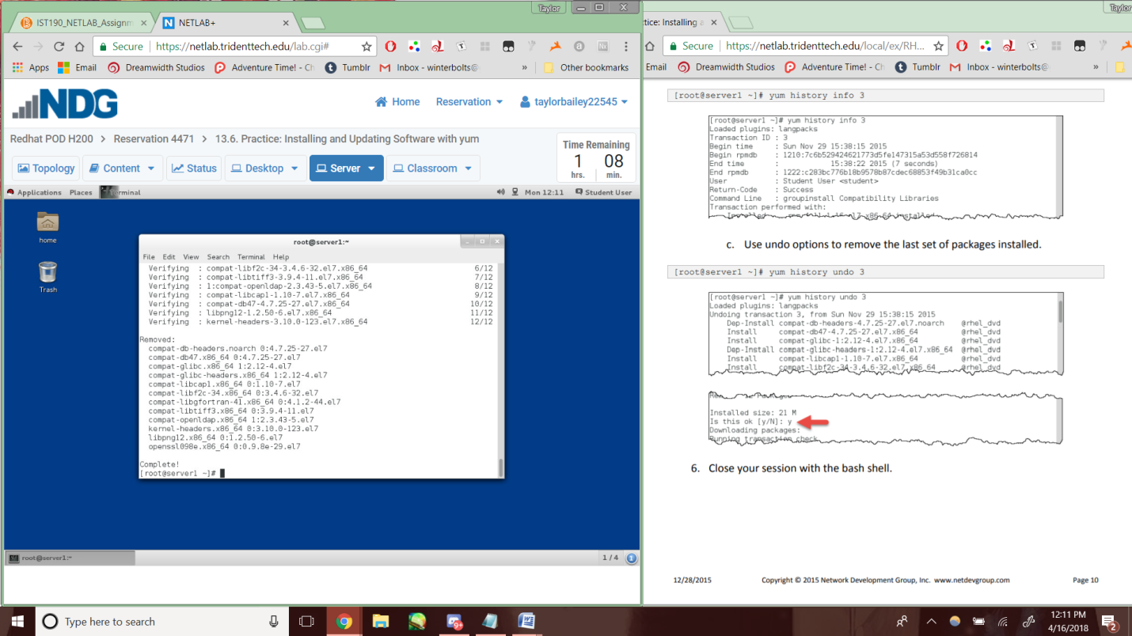

Lab7-13.8-6

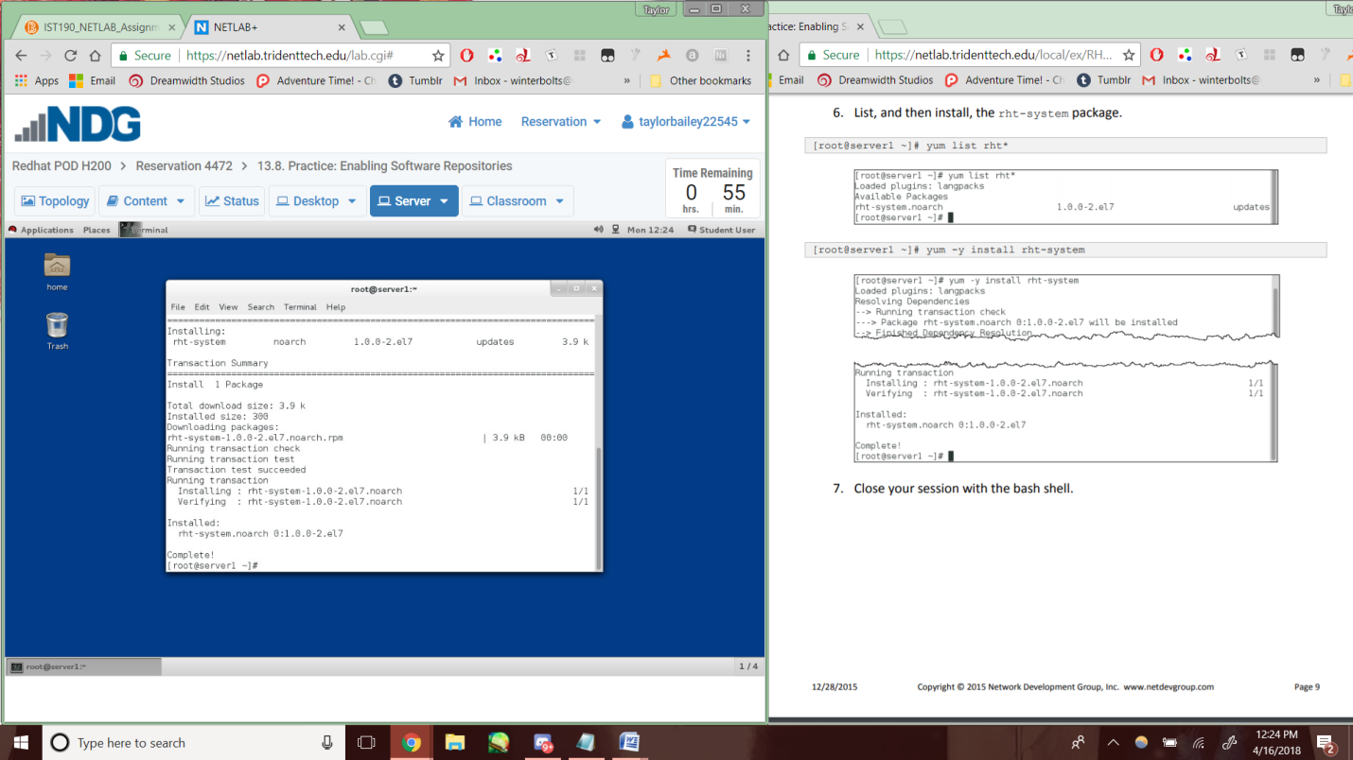

Lab7-13.10-5

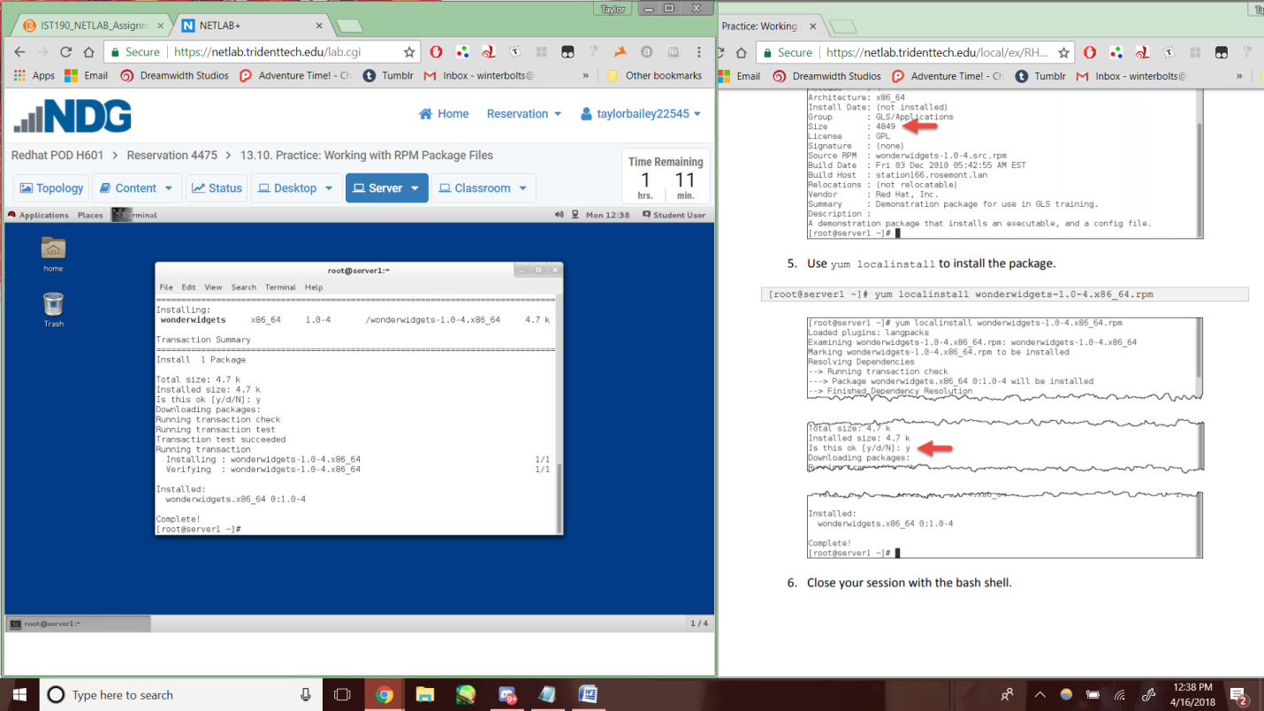

Lab7-13.11-4

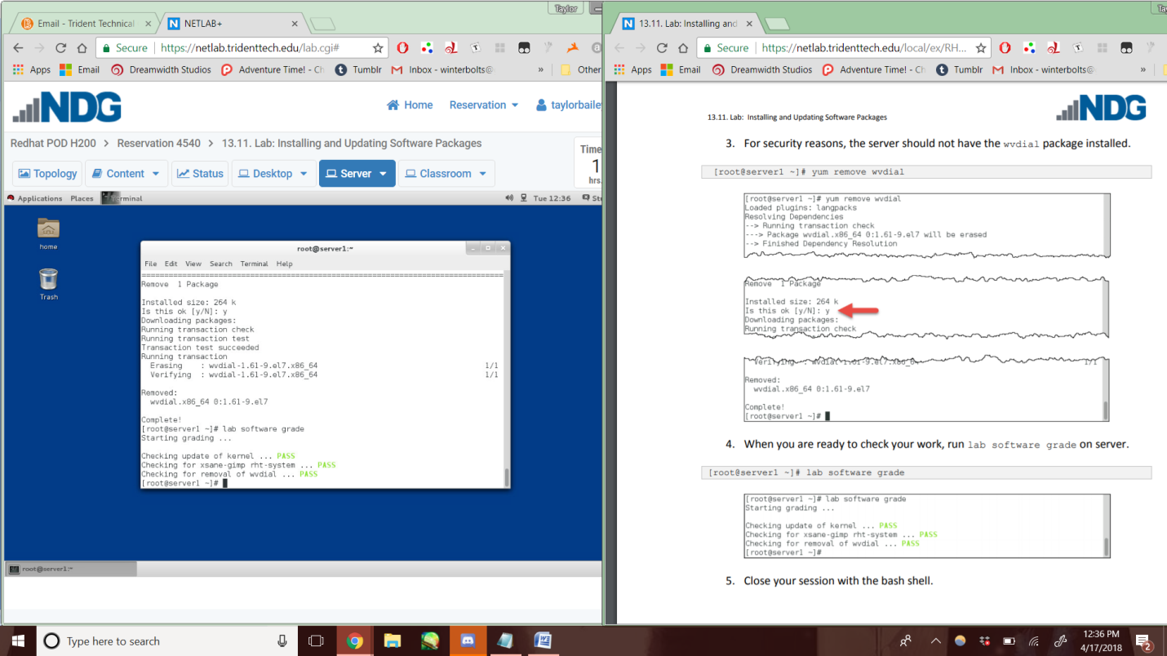

Lab7-14.4-4c

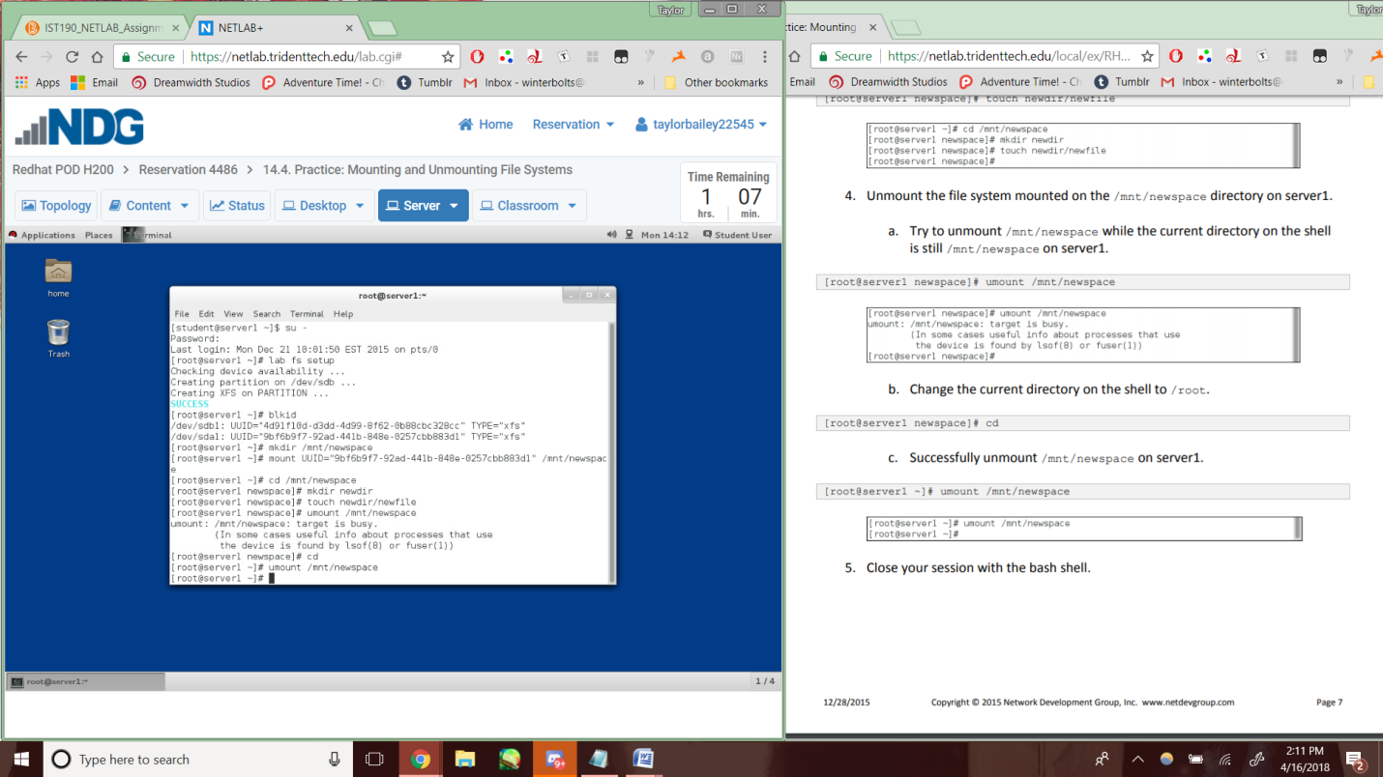

Lab7-14.6-2b

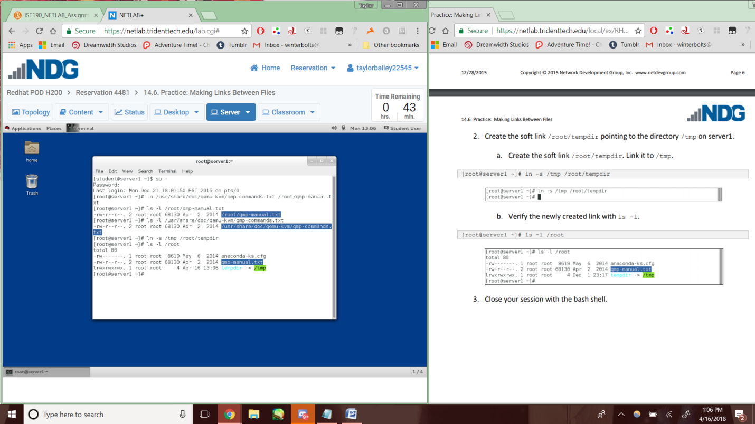

Lab7-14.8-2e

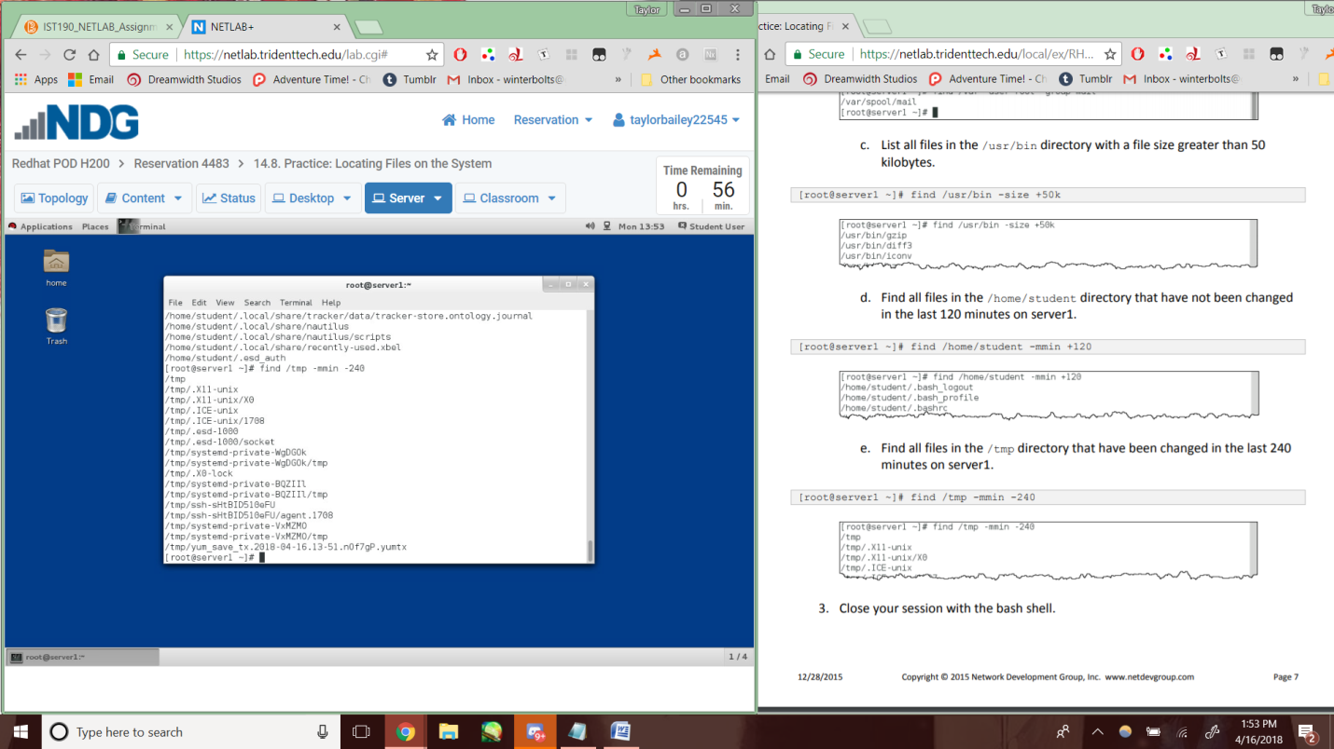

Lab7-14.9-5

